2.7 **Tractive system active light (TSAL)**

2.7.1 **Description/circuitry**

The TSAL consists of a RED and a Green RS PRO LED beacons (Appendix 12.1). The two LEDs are identical except the lens colour. They have 4 flashing modes: static, single, double, quad. The RED one was modified to flash at 2Hz (single mode) by bridge the white and red wires for 0.5 seconds. The GREEN one was modified to continuously illuminated (static mode) by connecting the same wires over 1 second. Table 2-11 lists the parameters of the TSAL.

|  |  |
| --- | --- |
| Supply voltage: | 10-100VDC |
| Max. operational current: | 100mA at 12VDC |
| Lamp type | LED |
| Power consumption: | 1.2 W |
| Flashing Frequency: | 2 Hz in Single Mode (RED), always ON in Static Mode (GREEN) |
| Size (height x base diameter): | 45mm x 77mm |

Table 2-11 Parameters of the TSAL

2.7.2 **Wiring/cables/connectors**

The three signals A,B,C which are described below determines whether the Tractive System is activated or deactivated.

The Tractive System is activated ($T$) when any the following signals are true:

* A: An accumulator isolation relay is closed.
* B: The pre-charge relay is closed.
* C: The voltage outside the accumulator container(s) exceeds 60VDC or 25 VAC RMS.

The Tractive System is deactivated ($\overline{T}$) when ALL of the following signals are true:

* $\overline{A}$: An accumulator isolation relay is opened.
* $\overline{B}$: The pre-charge relay is opened.
* $\overline{C}$: The voltage outside the accumulator container(s) does not exceed 60VDC or 25 VAC RMS.

The TSAL itself is red ($R$) and flash continuously with a frequency of 2 Hz if Tractive System is active ($T$), and the GLVS is switched on ($V$). It is green ($G$) and continuously illuminated if the Tractive System is deactivated ($\overline{T}$) and the GLVS is switched on ($V$).

In a word, the on and off of the TSAL can be expressed in the Boolean functions below.

|  |
| --- |
| $$A+B+C=T$$ |
| $\overline{A}$& $\overline{B}$& $\overline{C}=\overline{T}$ |
| $$R=T\&V$$ |
| $$G=\overline{T}\&V$$ |

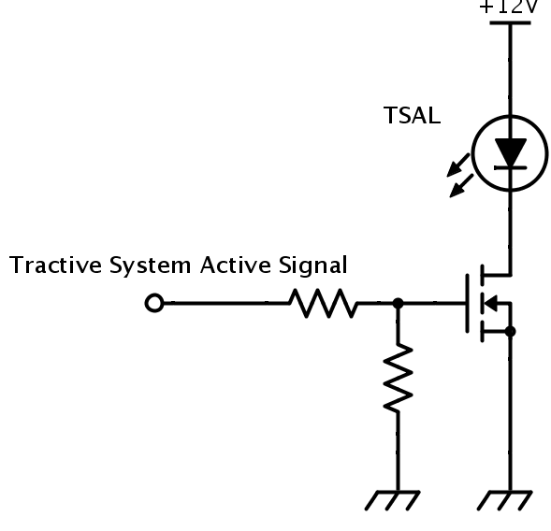The schematic in Figure 2.13 shows how the TSAL (RED/GREEN) is activated. When the $R$ or $G$ signal is high, the MOSFET drives the current for the light to turn on. Table 2-12 lists the wiring configuration of the TSAL.

Figure 2.13 TSAL

|  |  |  |  |
| --- | --- | --- | --- |
| Wire Label | Description | Colour | Type |
| TLW01A | From +12V to TSAL input |  |  |
| TLW02A | From TSAL to MOSFET Drain Connection |  |  |

Table 2-12 TSAL Wiring Configuration

The Resistors, MOSFET and digit circuit are located on a PCB in the Main electrical box.

2.7.3 **Position in car**

The position of the tractive system active light is shown in Figure 2.14.

2.12 **Ready-To-Drive-Sound (RTDS)**

2.12.1 **Description**The car will use an AE20M-24 Piezo Buzzer (Appendix 12.1) to generate the ready to drive sound. The buzzer has a sound level of 85dB. The sound will be activated when the car is in the ready-to-drive mode. i.e. when the tractive system is active.

(After the TS has been activated, additional actions must be required by the driver to set the vehicle to ready-to-drive mode (e.g. pressing a dedicated start button). One of these actions must include the actuation of the mechanical brakes while ready-to-drive mode is entered. From EV 5.12)

2.12.2 **Wiring, cables, current calculations, connectors**

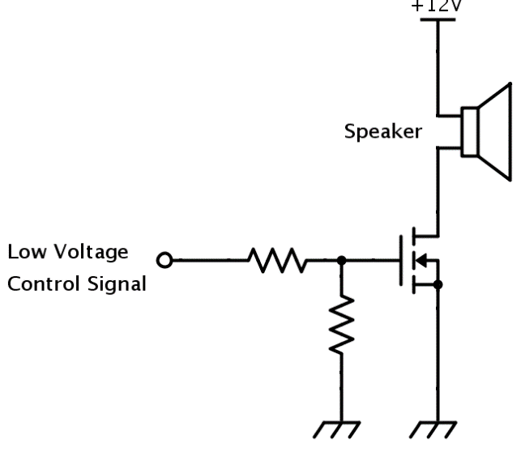The buzzer is driven by the main controller Arduino DUE which outputs a high signal when the use of a buzzer is needed. All of the connections of the ready to drive sound circuit besides the wiring connected directly to the buzzer are on a control PCB in the main control box. The buzzer draws 25mA by the specifications and as such type A wiring is used for the connections to it. The circuit of the ready to drive sound can be seen on Figure 2.27. Table 2-20 lists the wiring configuration of the ready-to-drive circuit.

Figure 2.27 Relevant connections of the Ready To Drive Sound buzzer.

|  |  |  |  |
| --- | --- | --- | --- |
| Wire Label | Description | Colour | Type |
| RTD01A | From +12V to Speaker |  |  |
| RTD02A | From Speaker to Main controller board stack |  |  |

Table 2-20 Wiring configuration of the read-to-drive circuit

2.12.3 **Position in car**

The speaker is located on the dashboard of the car, next to the display. The position of the buzzer can be seen in Figure 2.28.

Appendix 12.1

|  |  |  |  |
| --- | --- | --- | --- |
| RED Beacon | 2.7.1 | RS Low Profile LED Beacon, 10-100V | [Link](https://uk.rs-online.com/web/p/beacons/9075965/?fbclid=IwAR05b3dfQ3WdDS1RYTINFkmGlfrZl6qCOPn5s8zt5tN6P8oY_S8o4Vt9dSE) |
| Green Beacon | 2.7.1 | RS Low Profile LED Beacon, 10-100V | [Link](https://uk.rs-online.com/web/p/beacons/9075974/?fbclid=IwAR2A8D4nMJw5WkV4giay3gMd_lO1aFZWcTDRDpCg7ZoGzsDqQKiuvJmVXOg) |
| Siren | 2.12.1 | AE20M-24 Piezo Buzzer | [Link](https://uk.rs-online.com/web/p/buzzers/7216536/) |